**CHAPTER TWO**

**LITERATURE REVIEW**

**2.1 INTRODUCTION**

In the early 1990s some sectors of the computer science community were developing the idea of understanding as a discovery-driven, systematic and iterative process. This “Data Mining” Research and development area was expected to take advantage of the expansion of traditional statistical analysis and database management strategies. The main goal was to identify relevant, interesting and potentially novel information pattern and relationships, in large data to support system in areas such as finance (E.g. credit approval and fraud detection application), marketing and sales analysis (E.g. shopping patterns and sales prediction) were showing a great deal of enthusiasm about the business value of data mining applications. During the next few years international conferences, journals and books were more frequently reporting advances, tools and applications of other areas such as biomedical informatics, engineering, physics, law enforcement and agriculture.

Today, Data mining has become a fundamental research topic in the progression of computing applications in health care and biomedicine. Advances in data mining have applications and implications in areas ranging from information management in healthcare originations, consumer health informatics, public health and epidemiology, patient care and monitoring systems, large-scale image analysis to information extraction and classification of scientific literature. Approaches, techniques and applications associated with data mining has also significantly supported different data understanding and decision support tasks in bio-signal processing, Such as the classifications, visualization and identification of complex relationships between diagnostic variables or groups of patients.

Data mining is an inter-disciplinary subject formed by the intersection of many different areas, researchers in knowledge acquisition, artificial intelligence, machine learning, statistics, spatial database, and data visualization have also shown great interest in data mining. Since data mining poses many challenging research issues, direct applications of methods and techniques developed in related studies of machine learning, statistics and database systems cannot solve these problems, it is necessary to perform dedicated studies to invent new data mining methods or to develop integrated techniques for efficient and effective data mining. In this sense, data mining itself has performed an independent new field. The database research community has observed that data mining, together with warehousing and data repositories, is a new use of database technology, which are considered as important areas in database research (Xiaoling et al., 2023).

Due to its complexity, data mining technology has traditionally been used in scientific and engineering settings since it originated in university labs. Data mining is now growing common in business environments, particularly in companies with large volumes of data, communities of users, who are not data analysis specialists, and co-operate data that is detailed and multifaceted, with data relationships that are changeable, not predetermined or even logical([Nguyen](https://link.springer.com/article/10.1007/s10462-018-09679-z#auth-Giang-Nguyen-Aff1) et al., 2019).

In the business worlds, the most successful application of data mining is the “Market Basket” application. It is used to analyze transaction database and look for patterns among existing customer transaction. Those patterns are used to help make business decisions, such as what to put on sale, how to design coupons, how 20 to place merchandise on shelves in order to maximize the profit. Several successful applications have been developed for analyzing and reporting data changes. These include supermarket sale data and healthcare database (Verma et al., 2020).

A number of interesting and important scientific applications of data mining have also been developed. Example application areas in science include astronomy, molecular biology and global climate change modeling. Here we shall note that the manual search of data, search assisted by queries to a database management system (DBMA) or humans visualizing patterns in data are not referred to as data mining. This is how some authors examine data mining for Medical Record System of Hospital.

Advancement has also been made in connection with equipment in the hospital. There are machines like electrocardiograph system, blood cell separators, breathing aids, scan machines, heart monitoring machines etc. The theaters are filled with various life saving devices, many years ago these was not a reality about 26years ago you could access huge computers at a central location in some countries. Nigeria is not yet developed in computer industry unlike countries U. S, Germany etc. we are not yet developed into networking and most of the equipments mentioned above can only be found in few selected hospitals and at exorbitant prices with the effort government is making towards the computerization of every sector of the economy. It is believed that in no distant time the computer problem will become a thing of past.

Data mining can be defined as the process of finding previously unknown patterns and trends in databases and using that information to build predictive models (Inyiama et al., 2019). Alternatively, it can be defined as the process of data selection and exploration and building models using vast data stores to uncover previously unknown patterns (Agbaeze et al., 2019). Data mining aims at discovering novel, interesting and useful knowledge from databases.

Data mining, is the extraction of hidden predictive information from large database, is a powerful new technology with great potential to help companies focus on the most important information in their data warehouses (Chermiti , 2019).

Nanded also define Data mining in 2019 as tools predict future trends and behaviors, allowing businesses to make proactive, knowledge driven decisions.

The automated, prospective analysis offered by data mining move beyond the analyses of past events provided by retrospective tools typical of decision support systems (Mehrali et al., 2019).

Data mining tools can answer business questions that traditionally were too time consuming to resolve. The scour databases for hidden patterns, finding predictive information those experts may miss because it lies outside their expectations (Temirov et al., 2019).

**2.2 THE REVIEW OF RELATED LITERATURE**

The use of data mining for medical record system would be of help in serving an unusual case if not easily accessible. All these are what the new system purposes to climate or minimize([Ed-daoudy](https://link.springer.com/article/10.1186/s40537-019-0271-7#auth-Abderrahmane-Ed_daoudy-Aff1) et al., 2019).

Data mining researchers are mostly thinking of creating some data mining systems which can automatically do the entire knowledge discovery tasks without human participation. The user can get the result after a start button. But when we think of the problem practically, quite often the computers do not work so well as we expect because currently computers having human-level intelligence are only a dream. If we have computer do all the knowledge discovery work, sometimes we will have the task done in a “stupid” way by the computers, while an experienced human worker can do it more efficiently and with better result if the data amount is within human ability, thus human guidance, expertise, and experiences are currently irreplaceable in discovering and understanding knowledge.

Data mining for medical record system excludes the informal (manual) collection of data, it exists as a separate entity within an organization, and it could be simply viewed as the container of data. The healthcare service being the most delicate important aspect of service being rendered to the people at the hospital deals with life and must be treated with care. It has gone through various developments over the years.

File maintenance is possible with medical record system by computer. Furthermore, the reports compiled by the computer are more reliable than the medical data kept by most record unit workers.

Another help of data mining for medical record system in medical information system (MIS) of patient that need to transplant of one organ or the as well as the record of voluntary donors through a network database system, hospitals all over the world are able to receive and send information through the network. For instance, when a kidney is available for transplanting, through the network they are able to get in touch with a patient that needs the kidney living in other part of country. This saves time and life of the patient unlike in a situation where information has to be sent by post.

This has really saved the life of many patients who would have died due to the prolonged time lapses in the course of waiting for information. Not too long ago, the popular Nigeria broadcaster, Steve Kadiri was one of such patient who was in need of kidney transplant. The kidney type was not match with many donors type present in the country and information was gotten from the network as to the most fitted and available kidney.

**2.2.1 METHODOLOGY**

The methodologies viewed in the related research include the Cross –industry standard process for data mining (CRISP-DM) and Structured Systems Analysis and Design Methodology (SSADM). CRISP-DM has different phases which include Business or Project understanding, Data understanding, Data preparation, Modeling, Evaluation and Deployment. In this research Crisp -DM was used to analyze the hospital’s needs, requirements, goals, and strategies. Hospitals, for example, may need to extract information from their data warehouses either on a one-time basis or on a recurrent one, then the data collected will be evaluated to know whether it is of value before deploying it for use. Structured Systems Analysis and Design Methodology (SSADM) is a system approach to the analysis and design of information systems.

This approach is mainly designed for large scale information systems with high volume of business activities. SSADM starts from defining the information system strategy and then develops a feasibility study module. These are followed by requirements analysis, requirements specification, logical system specification and a final physical system design. In this research SSADM was used to collect information to analyse the problem, proffer solution to the problem and documentation of work.

**2.2.2 RESULTS**

The figures below show the medical history of the patients which includes the Patient’s name, address, ID number, diagnosis, vital signs and treatments given to them. The information from here can be used to know the most effective treatment that can be used to treat patients.

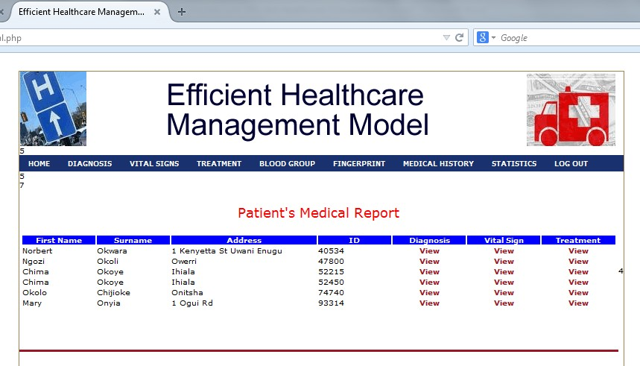

# Figure 1: Patient’s Medical History

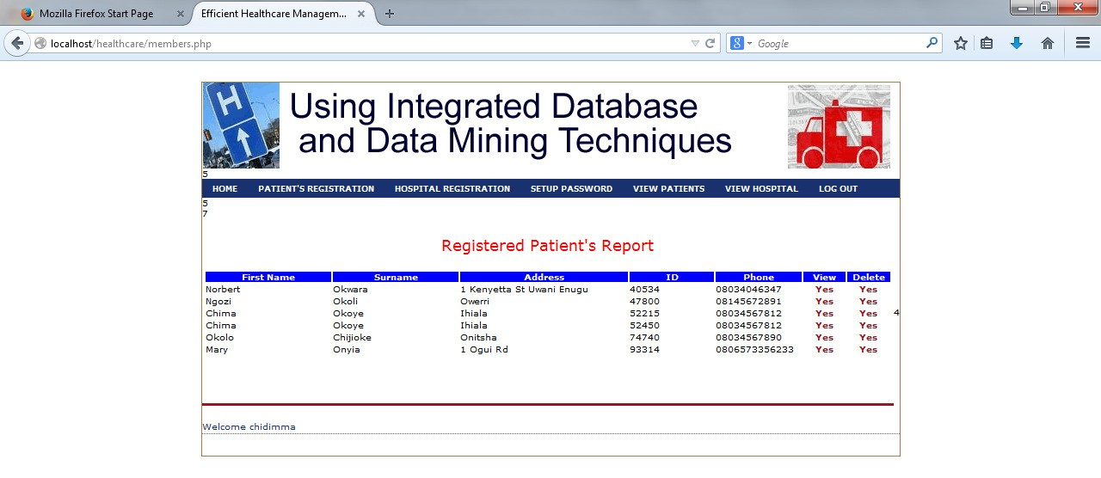

# Figure 2: This shows Patient’s registered report

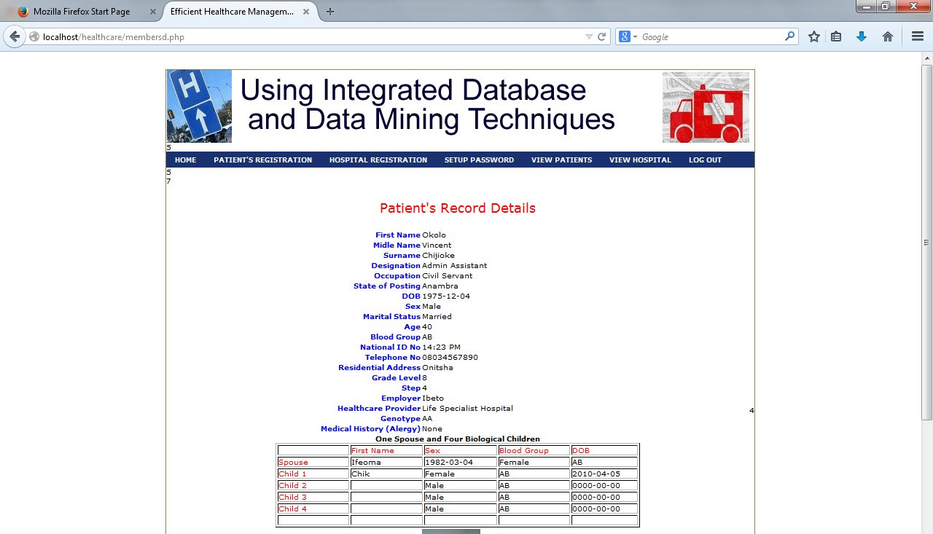

**2.3 CONCEPTUAL FRAMEWORK**

Based on the analysis of the above evaluation studies, we propose four fundamental health sector website assessment criteria ‒ Content, Technology, Services and Participation ‒ which cover the whole spectrum of the identified assessment elements of our literature review.

The table below shows Criteria and indicators allocated to each of them:

|  |  |  |  |
| --- | --- | --- | --- |
| Content | Technology | Services | Participation |
| Hospital Information Quality Metrics  Organisational Structure  Medical Information Patient Information Research and Teaching | Navigability  Navigability Accessibility Usability/Readability Credibility Privacy/Security | Administration Procedures Appointments  Patient Care  Inter-Hospital Communication Communication  with Others | Community Interaction  Media Advertising/Marketing |

**2.3.1 Content**

criterion evaluates the presence of information relevant to the user. It evaluates the quality, availability, relevancy, completeness and concise representation of specific information that it is expected to be provided in a health’s sector institution website. Thereinafter the proposed indicators are analysed.

**2.3.1.1 Hospital Information**

Most of the hospitals provide general health information . The simplest health sector websites consist of electronic versions of their printed materials. Using these capabilities, a hospital website can provide up-to-date information in a cost effective and involving manner. Hospital designation and logo on the home page are usually included in the home page . Almost all sites include information such as a general phone number for the hospital, fax number, postal address, e-mail address, VAT number, a map or directions to the hospital, parking information, transportation information and a history of the institution. Additional elements are illustration of complementary services (press, cafeteria, Wi-Fi, telephone etc.), phone directory of the institution and emergency information. Few take advantage of the available technology to provide a virtual tour of their facilities.

**2.3.1.2 Quality Metrics**

Public reporting of hospital quality data, empowers patients, referring physicians, and purchasers of health care with the information needed to make informed decisions regarding their care. It also encourages hospitals and physicians to participate in continuous performance improvement by creating a healthy and competitive environment for better patient outcomes. Consequently, more and more hospitals are considering reporting their organizational quality metrics on their websites. Quality elements include the waiting list, the number of available beds, the admissions number report, the nosocomial infection rate, the inpatient mortality rate and the surgical mortality rate.

**2.3.1.3 Organisational Structure**

The organisation chart depicts institution’s structure, it defines the hierarchy and the different roles that are involved. Emphasizing on openness and accountability and attempting to make the provided services more patient-centred, lead hospitals to publish their services charter. Essential information is the list of clinical services avail-able at the hospital, the list of outpatient hospital services available (consultation, diagnostic services), the list of departments or units providing patient services, their relative working hours, their locations and their contact details.

**2.3.1.4 Medical Information**

Hospital physicians should have their own place on a hospital's website given their importance to the success of a hospital. Clearly, there is an incentive for hospitals to link website visitors with doctors having an existing relationship with the hospital. For potential patients, an electronic version of doctors printed directory is essential. Apart from the list of employed doctors, sites should include doctor's phone number, email address, picture, education/certification and relative practice information. In this section health-disease specific information and relative treatment information is included .It should also be provided the possibility to read online or to download health-care booklets and a medical glossary.

**2.3.1.5 Patient Information**

A clear description of patient’s rights and obligations is essential. Information that should be adequately addressed is the related indications for hospital admission and discharge. The website contains different types of admission, information and rules to be followed on admission, during hospitalisation and discharge as well as information to obtain a copy of the medical documents. It also provides information for visitors. Details of how to pay prescription charges, about private consultations/services and fees and information for foreigners is provided in this section.

**2.3.1.6 Research and Teaching**

Many hospitals have a teaching mission. Those institutions include in their website, information about graduate medical education in general and information for medical students, undergraduate or postgraduate courses that are held at the hospital, schedule of activities that take place at the hospital (courses, workshops and conferences), scientific studies that the hospital promotes or is involved in and publications of the hospital itself. Hospital libraries represent the most accessible source for medical information and services. Doctors, nurses, and other health professionals request information from hospital libraries related to a current case or clinical situation. The ability of hospital’s website to provide relative information about the library presence, address, working hours, publications catalogue and available services (reading, loans, copies) is important.

**2.3.2 Technology**

This criterion appears to be a mixture of, mainly technical, items that relates to easy navigation, website quality, visual appeal, functionality and reliability. The technology criterion is related to how the content and services are assembled and made available on a website. Technology criterion is analysed in the following indicators.

**2.3.2.1 Navigability**

Navigability indicator examines the easiness that the user finds the required piece of information by moving through the website. Elements that are evaluated include effective use of hyperlinks and the degree to which the interface helps the user orient himself within the website.

**2.3.2.2 Accessibility**

Accessibility indicator refers to the practice of removing barriers that prevent interaction with, or access to website, by people with disabilities or people with restricted computer literacy. Elements that should be addressed include semantically meaningful HTML tags, textual equivalents provided for images, links named meaningfully, text and images that are large or enlargeable, flashing effects which are avoided or made optional, content that is written in plain language, compliance with WCAG W3C guidelines, compatibility with different browsers and access from various devices.

**2.3.2.3 Usability/Readability**

Usability indicator evaluates the ease of use of the website. Information should be presented concisely, without ambiguity and each item should be placed in the appropriate area. Some of the common aspects of usability are simplicity, consistency, familiarity, clarity and relevancy. For prospective and current patients to effectively use the information available at a hospital's website, they must have a search tool. A search engine allows a patient to locate information without knowing how the hospital has organized website’s content. Other essential features include website map, content in foreign languages, quick load time, graphics that open conveniently, website pages that can be printed, individual sub-pages that have specific and meaningful titles.

**2.3.2.4 Credibility**

Because of the critical role of hospital websites in human’s health, credibility indicator is critical. Elements that should be evaluated include author and date of the provided information and the text quality which should be grammatically and spelling correct. Interest conflict declaration, date of last website update, HON (Health on the Net) foundation code certification, webmaster characteristics and sources and references should be clearly listed.

**2.3.2.5 Privacy/Security**

Health sector website privacy holds profound implications since service delivery impacts human life, legality and social policy. Related information presentation and dissemination has raised privacy concerns among both consumers and providers. A privacy policy describing the website’s information practices should be easily accessible on the site. Issues regarding patient confidentiality, copyright notice and terms of use, must be specifically addressed to become widely available.

Inclusion of trust symbols (e.g. Verisign) allow a hospital website to stand out from the increasingly crowded internet marketplace. Security management tools and usage is an important part of the website. Other elements included in this indicator are general disclaimers, ownership of the site and provision of a secure website using encryption techniques (e.g. HTTPS).

**2.3.3 Services**

The growth of consumerism and the proliferation of internet accessible sources of healthrelated information have modified the traditional roles of provider and patient. The trend towards creating individual patient profiles personalising the provided electronic services can bring many benefits to both hospital and patient. Personalised content can be provided during interactions with all users and this might improve loyalty to a particular hospital.

This criterion includes electronic healthcare scheduling, prescription renewal or drug acquisition, automation of hospital’s back-office procedures, forms availability on website, electronic completion of administrative transactions and on-line appointments.

**2.3.3.1 Administration Procedures**

Health institutions can use online forms or provide standardised documents for downloading and uploading, to their users. In this way, they simplify and optimise the administrative interaction with their customers. Taking this notion one step further, they can establish the use of digitally signed documents enabling the full electronic administration cycle.

Experiences in other e-commerce areas create high expectations to hospital customers for what is possible. Hospital websites are expected to facilitate interaction between visitors and the hospital staff. In order to achieve cost savings and streamline the treatment, hospitals allow visitors to submit e-mail requests for general health information. Some of them provide the capability for referring doctors to use e-mail referral forms or furthermore enable interactive communication applications.

**2.3.3.2 Appointments**

Translating visitor’s interest in a hospital into action is one of the most important purposes of a hospital website. Online appointments and user membership registration are functions that should be included. Some hospitals enable their customers to interactively schedule appointments via web forms or via e-mail. These forms include the patient's phone numbers, address, reason for appointment, best time to reach and preferred location for appointment. Some websites include a printable checklist of items to bring to the hospital in the appointment.

**2.3.3.3 Patient Care**

Features evaluated in this indicator provide an important link between patients and hospitals. Supporting professional practice, asynchronous communication between the patient and the physician is implemented through email or through web-based message exchange systems. Some hospitals offer real-time chat sessions between doctors and patients, providing in this way the opportunity to the patient to pose follow-up questions. Through their websites, hospitals provide access to patient’s medical records system that creates and maintains all patient data electronically. The system captures patient data, such as patient personal data, requests, lab orders, medications, diagnoses and procedures, at its source at the time of entry.

**2.3.3.4 Inter-Hospital Communication**

Ubiquitous, secure electronic exchange of patient’s clinical data and patient’s record among hospitals/laboratories, through appropriate web interfaces, helps lessen the disruption from parallel electronic and paper-based medical record systems, thereby decreasing physician time costs and optimising service provision to the patient.

**2.3.3.5 Communication with Others**

Electronic exchange of data and documents with other organisations, especially with public administration authorities, exploit the existing possibilities to automate bureaucratic procedures completion.

**CHAPTER SUMMARY**

Our review of related research has shown that hospital website assessment process can be based in four criteria, content, technical, services and participation. We identified indicators which can be used to assess the above criteria. Our framework has been designed to focus on how a specific health sector institution website applies its goals and objectives. The framework could help hospital management, health sector officials and website managers to understand causal links that show ‘‘how’’ and ‘‘where’’ a website is consistent with its strategy. This study should also be of interest to technology practitioners and researchers, as the findings shed light on the further development of performance measurements for hospital websites. To fulfil a strategic evaluation, we recommend that domain experts have a better understanding of the website’s aims and evaluate the site according to those.